AI Use Declaration Form
Course: Introduction to Artificial Intelligence
Lab Title: Lab 2: Predictive Analytics with Machine Learning
Student Name: Remy Nteziryayo
Student ID: 90102028
GitHub Repository Link: https://github.com/Rems-dev1/lab-2-predictive-analytics
Date Submitted: 03/07/2026

1. AI Use Summary
Question | Student Response
Did you use any AI tool for this lab? | Yes
Estimated percentage of the work influenced by AI | 15%
Did you attach evidence of AI use where applicable? | Yes

2. Details of AI Use
Complete the table below for each AI tool used. Add more rows where necessary.
Name of AI Tool Used | Purpose for Using the Tool | Prompt or Instruction Given to the Tool | Part(s) of the Work Influenced by the Tool | How I Verified, Edited, or Improved the AI Output
Gemini | Explaining concepts and guidance | I want you to act as my personal AI, Python, and Search Algorithms tutor.  I am a complete beginner. Assume I have never studied Artificial Intelligence,.  Your goal is to help me fully understand the attached lab document so that I can complete every task myself and confidently explain it to someone else.  Important teaching rules:  Do NOT directly answer any TODOs, coding exercises, self-checks, custom maps, reflection questions, or assignment questions unless I explicitly ask for the answer later.  Teach me step-by-step before expecting me to write code. | Explaining to me the meaning of the output and interpreting things which are challenging for me | I verified to see if the output does not have errors or is out of range of the scope of these exercises.

3. Attachment of AI Output Evidence
Where required, attach evidence of AI use. Tick all that apply. Add more rows where necessary.
Evidence Type | Attached? (Yes, No, N/A) | File Name
AI-generated draft | No
Prompt history | No
Screenshot of AI interaction | Yes | Found at bottom of this page
Exported AI conversation | No
AI-generated code snippet | NO
Revised version showing student input | No

4. Student Declaration
I declare that:
Declaration Statement | Response (Yes/No)
The submitted work is my own work. | Yes
Any use of AI tools has been clearly declared in this form. | Yes
The prompts, instructions, and AI-generated outputs have been disclosed where applicable. | Yes
I reviewed, tested, edited, and improved any AI-generated content before submission. | Yes
My AI usage does not exceed 25% of the entire work. | Yes
I understand that undeclared or excessive AI use may be treated as academic misconduct. | Yes

Student Signature: Remy Nteziryayo
Date: 20/06/2026

Attachments:
- 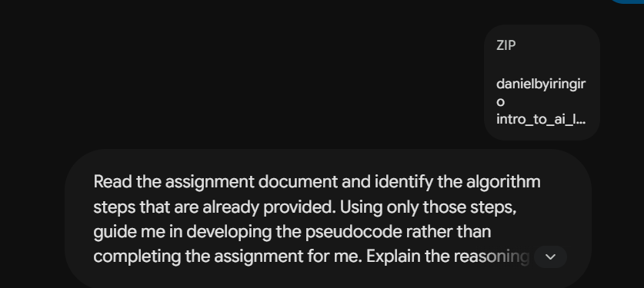

AI answer:

